Supplementary 2. ROC curves overtime to visualize the predictability of the model overtime for mortality prediction.
A: Model: Age+MELD
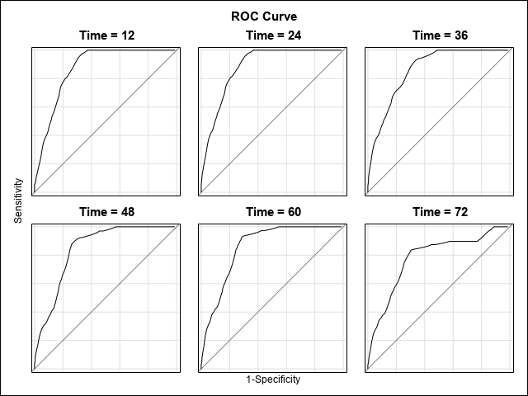
AUC by time
12 months: 0.871
24 months: 0.884
36 months: 0.861
48 months: 0.844
60 months: 0.858
72 months: 0.781
B: Model: Age+MELD+IR
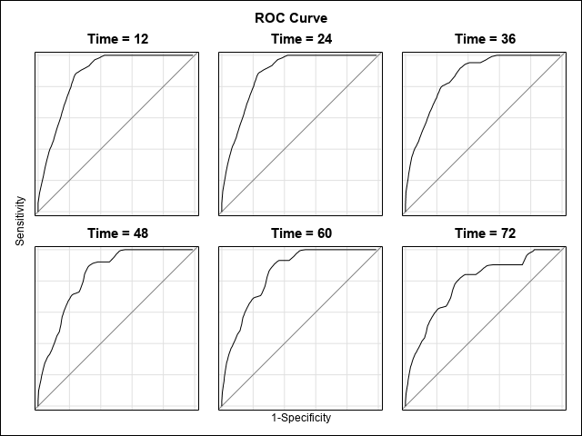
AUC by time
12 months: 0.874
24 months: 0.883
36 months: 0.862
48 months: 0.838
60 months: 0.850
72 months: 0.784

C: Model: Age+DF
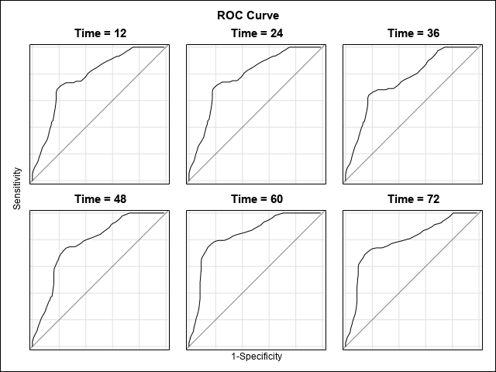
AUC by time
12 months: 0.777
24 months: 0.783
36 months: 0.757
48 months: 0.776
60 months: 0.838
72 months: 0.790

D: Model: Age+DF+IR
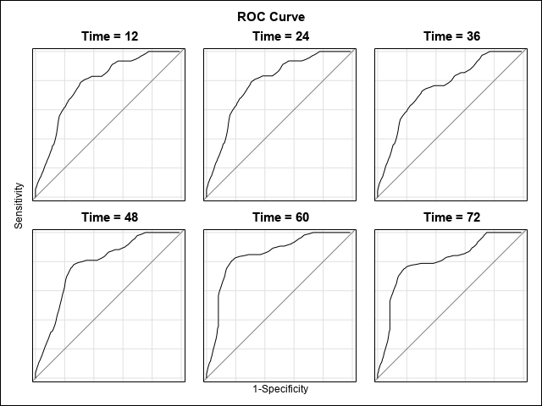
AUC by time
12 months: 0.783
24 months: 0.788
36 months: 0.757
48 months: 0.780
60 months: 0.847
72 months: 0.803

E: Model: Age+MELD+Albumin
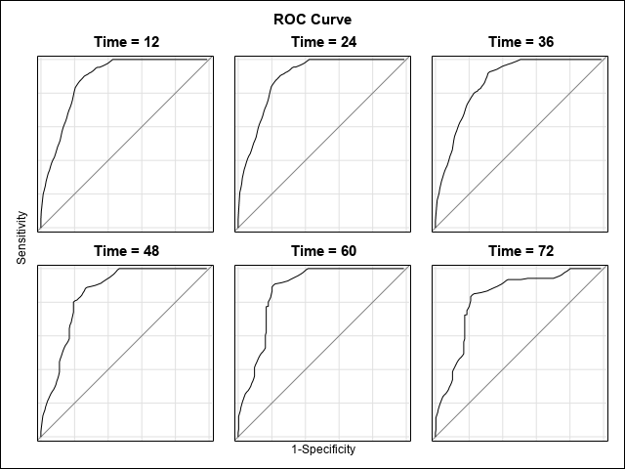
AUC by time
12 months: 0.880
24 months: 0.889
36 months: 0.866
48 months: 0.854
60 months: 0.872
72 months: 0.827

