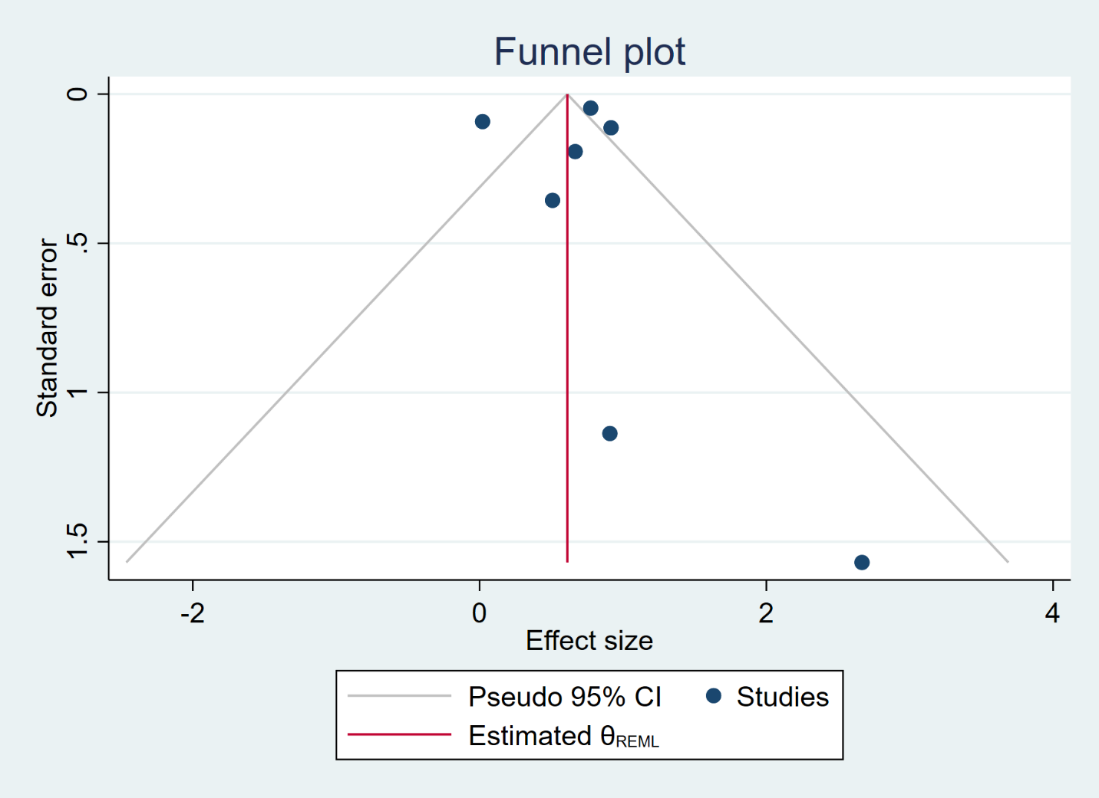

Supplementary Material 2. Funnel Plot of included studies

