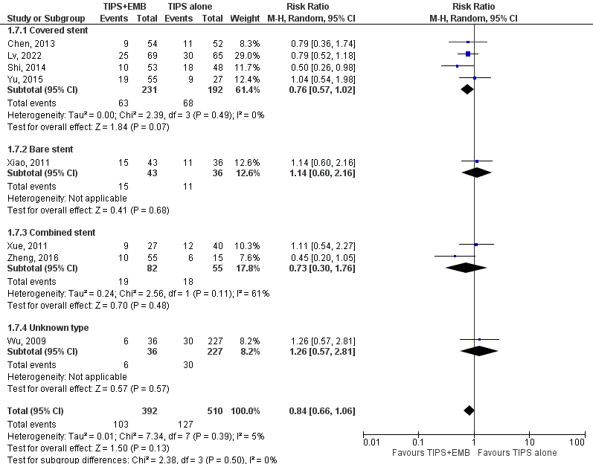

Supple 2. Forest plots of meta-analyses comparing the incidence of encephalopathy between the TIPS alone groups and TIPS combined with variceal embolization group (TIPS +EMB) based on stent types ( covered vs. bare vs. combined vs. unknown).

