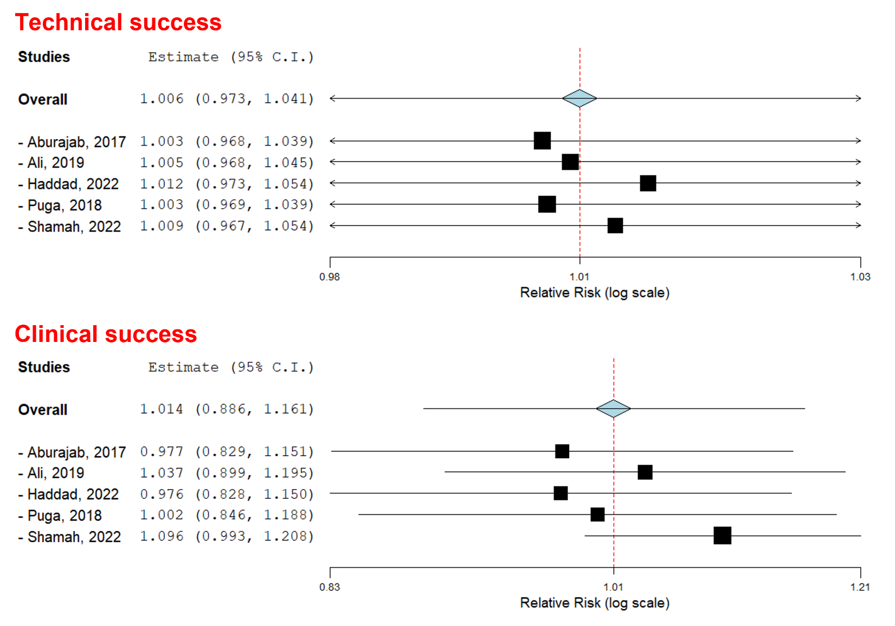
Suppl 3. Leave-one-out sensitivity analysis for overall adverse events, stent migration, and bleeding.

